# Stage 1: Development

As there are well over seven thousand lines of code in my software solution, I encourage you to scan through the Python backend and JavaScript files in my GitHub repository. There are header comments for each of the files and methods in just about every file, which explain their purpose and explain what sorts of parameters they take, the type of, and what the different response codes mean. There is a developer log ‘dev log’ at the bottom of *main.py* annotating my development process throughout the month.

## Code Repository

[Serpyne/StorageSaver: SAT Project for VCE Software Development 3/4. (github.com)](https://github.com/Serpyne/StorageSaver)

* [files/upload.js](https://github.com/Serpyne/StorageSaver/blob/master/project/static/js/files/upload.js)
* [files.py](https://github.com/Serpyne/StorageSaver/blob/master/project/files.py)

However, I will only include screenshots of the necessary methods for the program to run and process as efficiently as it does. Furthermore, some of these methods are crucial to improve the application’s usability and ease of file management.

Contents

Stage 1: Development 1

Code Repository 1

Linear Search Algorithm 3

Password Check 4

Hash Function 5

Encryption and Decryption 6

Binary Search Algorithm 7

Reverse an Array 8

Quick Sort 9

Sorted by Name, Ascending 11

Sorted by Type, Ascending 11

Sorted by Size, Descending 11

Checking Filenames (Maintainability) 12

Formatting File Size, Date, and Time 13

Interface 14

Menu 14

Profile 15

All Files 16

Gallery 18

File Manager 20

Recently Deleted 21

About Us 21

## Linear Search Algorithm

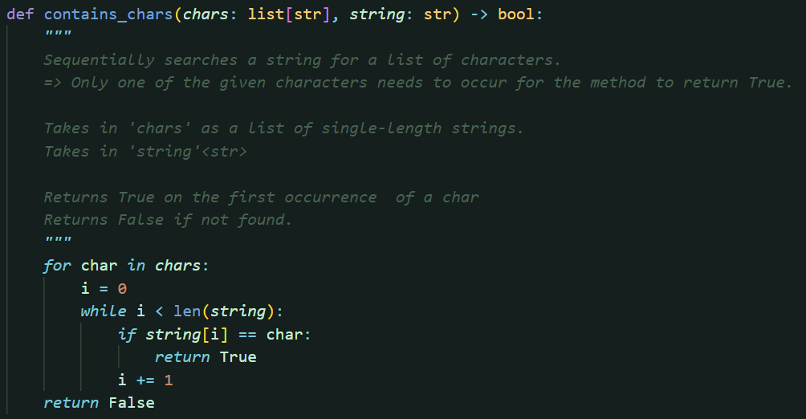

This algorithm searches a string for any number of given characters. It will return true once the first occurrence of any character is found. However, if it goes through all of the characters and none of the characters match, the method will finally return false.

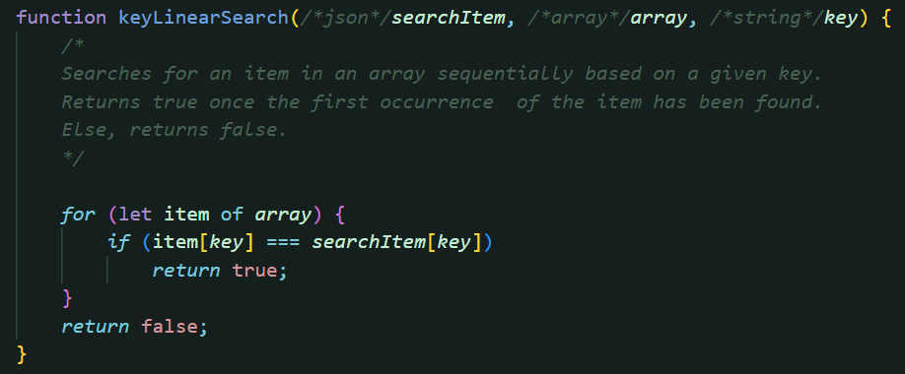

*The same implementation in JavaScript, but to search an array of objects for an object, based on a given key/property.

## Password Check

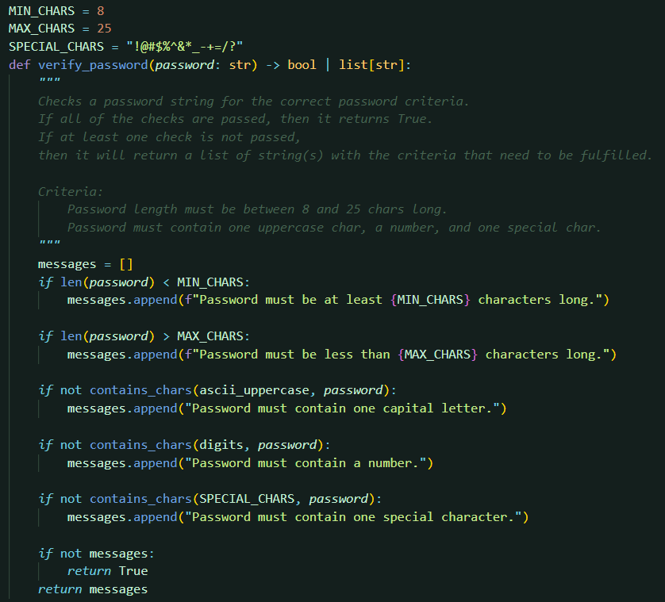

This method is called when an account signup request is made. It makes use of the previous method by checking if the password contains both numerical and special characters. To improve readability, the if statements check if a criteria is *not* met. If so, then it will add an error to the list of messages, which is sent back to the user’s web client. If there are no messages after all of these checks, we can safely conclude that all of the criteria have been met.

## Hash Function

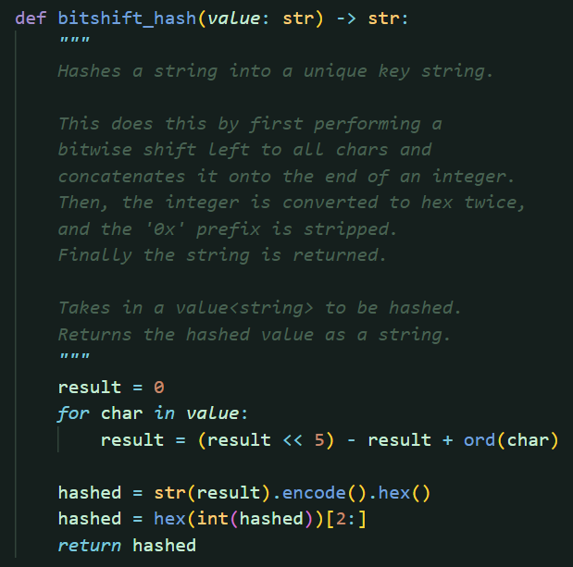

The hash function is called once the password check returns true. It is used to hash the password to be stored into the user database. After the hash function has been applied, it is very difficult to be inverted. Therefore, this method is very useful, as the backend never has to unhash a password during comparison, it just has to apply the hash function the given password and compare it with hashed passwords in the database.

It makes use of a hash code computation algorithm that I found at [Hash Tables · Data Structures (maximal.io)](https://datastructures.maximal.io/hash-tables/), but modified slightly to be converted to a hexadecimal string at the end of the hash function.

A hashed password looks like this:



## Encryption and Decryption

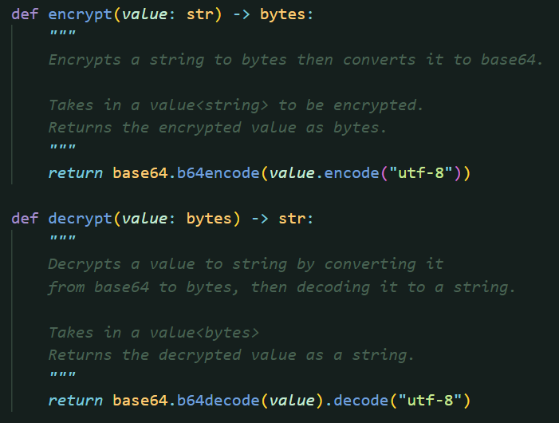

These methods are complements of each other. They are called during the accessing and modification of user settings. Encryption differs from the hash function previously mentioned, as the encrypted string can then be decrypted using its inverse function.

Therefore, the JSON version of a user’s settings is converted to a string and then encrypted, to be stored in the database. In future, It would be a better practice to use more ambiguous cryptography functions (and also to not store it on a public repository) such that user settings are much harder to access.

A example of encrypted user settings look like this:

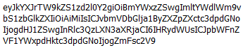

## Binary Search Algorithm

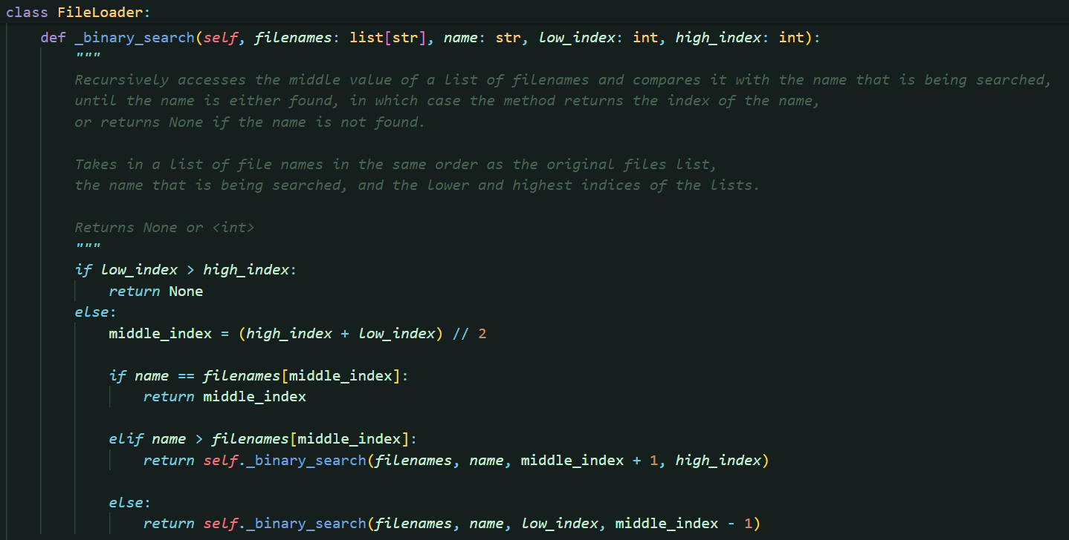 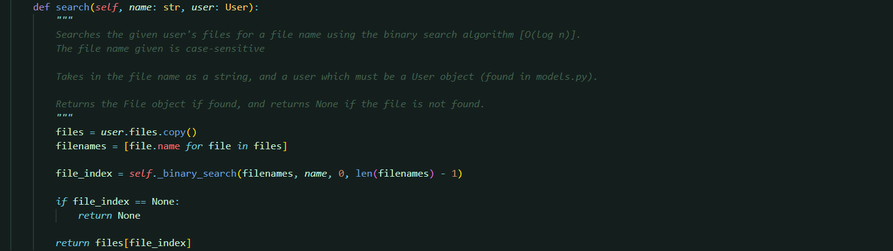

The search method is called whenever the backend queries individual files by their file name, such as getting, copying, renaming, uploading, and checking for duplicate files.

Note that whenever new files are added, they are always placed in alphabetical order according to the file’s name (This is automatically done by the SQL database). Hence, the binary search algorithm is able to work as it requires the list to be sorted.

Since the files are stored as File objects, a separate ‘filenames’ list is created. Then, the binary search is performed on the list of file names to search for the given name. If it is found, it will return the index of the file name, which can then be used to index the original files list. However, if the file name is not found, then it will return none.

Strings in Python can be compared with the greater or less than operators. This is why the file names are case sensitive as making all strings lowercase will mean that storing the files in sorted order is redundant.

## Reverse an Array

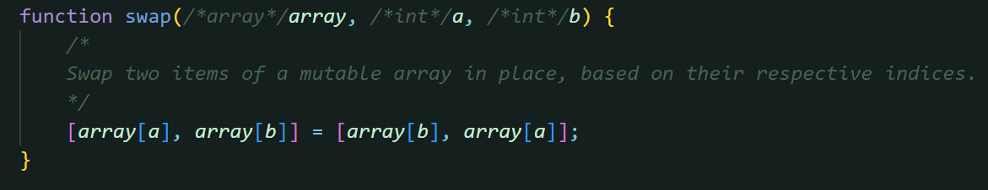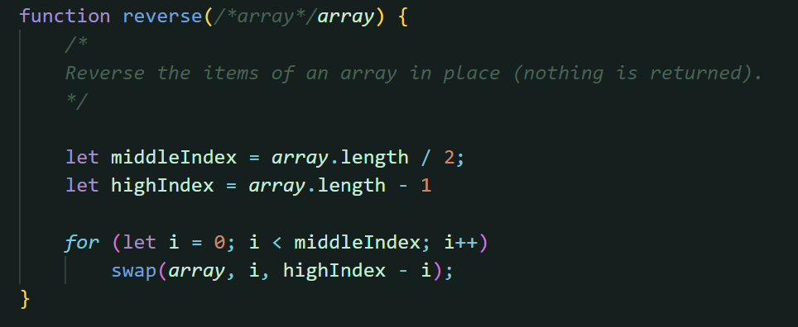

The swap function makes use of JavaScript’s array properties. Traditionally, a temporary variable must be written to for a swap to be performed. In this case, we are able to skip the additional step.

To reverse an array, an index is set to the first element of the array. A swap is performed for the indexed element and its mirror (the length of the array minus the index). This is looped until the index reaches the middle of the array. Finally, we have reversed an array in place.

## Quick Sort

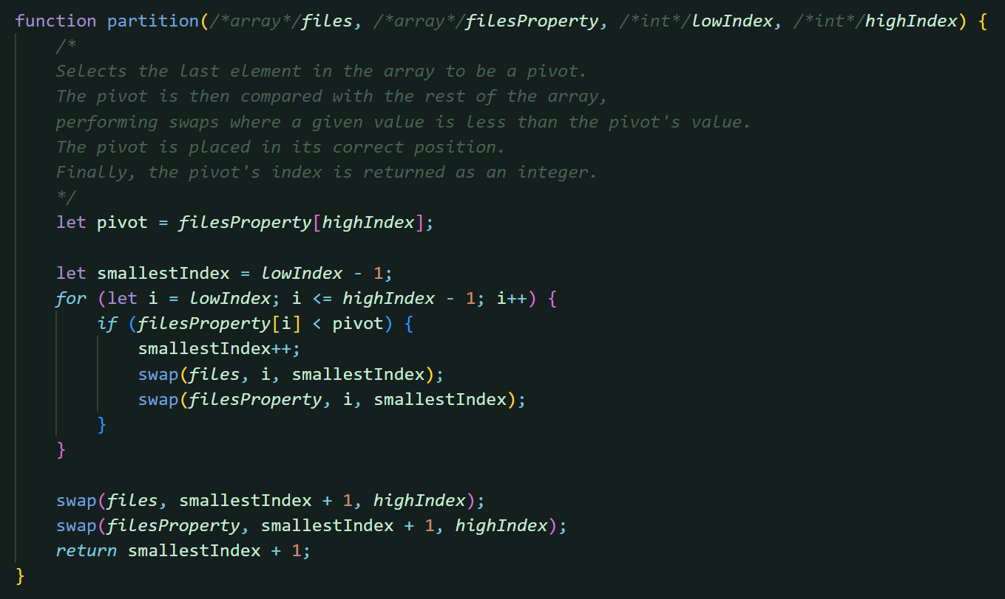 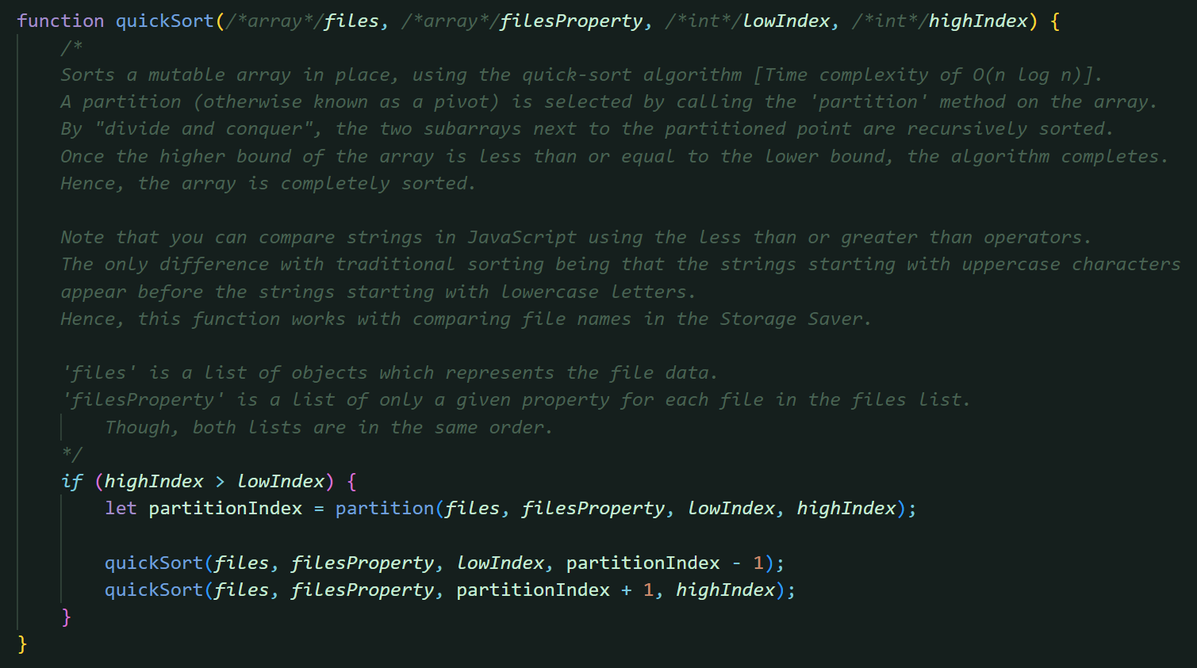

This function differs from the typical quick sort algorithm as we are working with a different format of array. I have stored my files as an array of objects. Therefore, to sort by a specific property, the property must be accessed from each object and then placed in its own array (in the same order).

As the swap function performs a swap on an array in place, there must then be two swaps performed for every swap originally, to accommodate for the two arrays. The quick sort function still recursively calls itself until all subarrays are sorted.

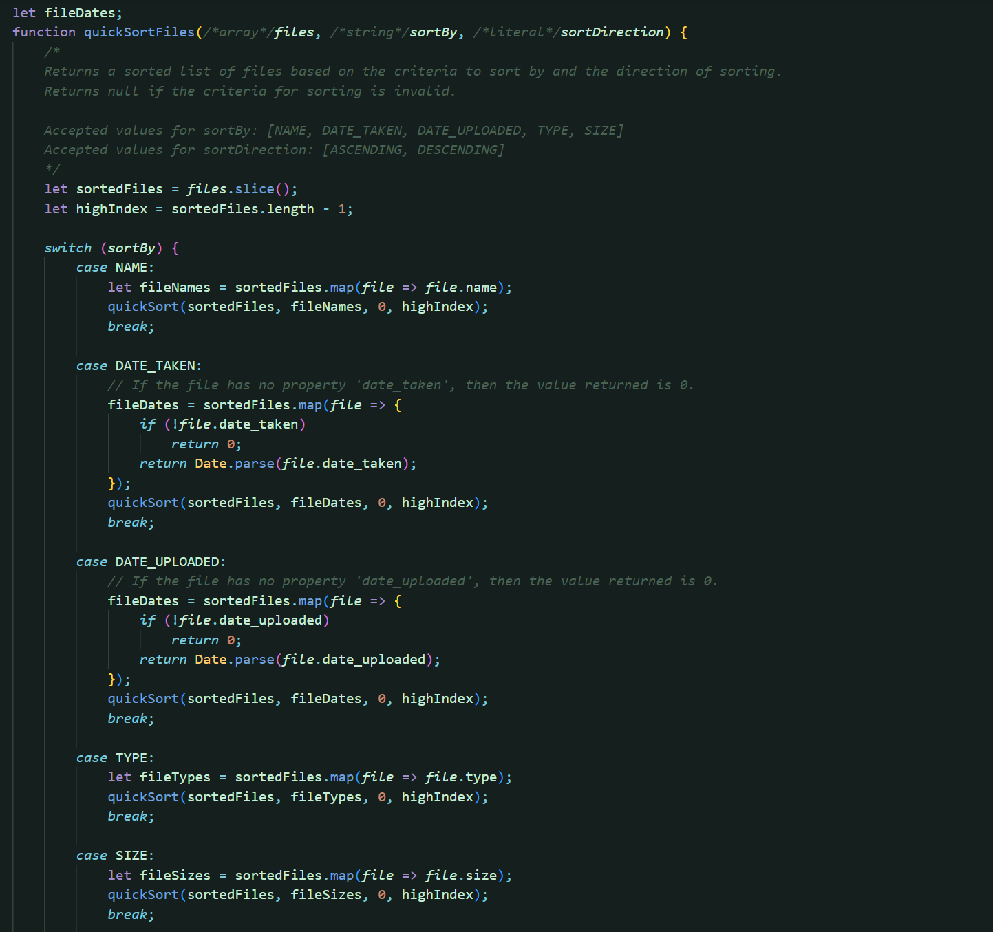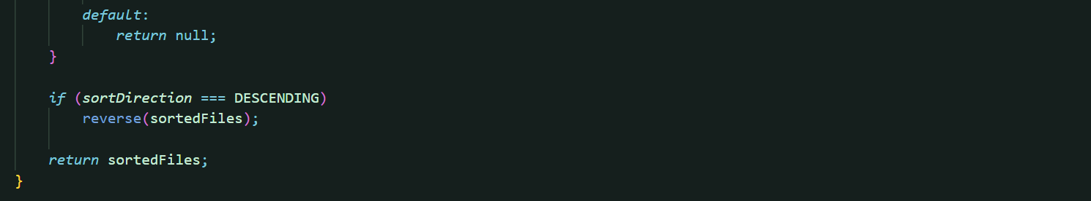

This is my implementation of sorting by individual properties of the files. On the next page, you will see a demonstration.

### Sorted by Name, Ascending

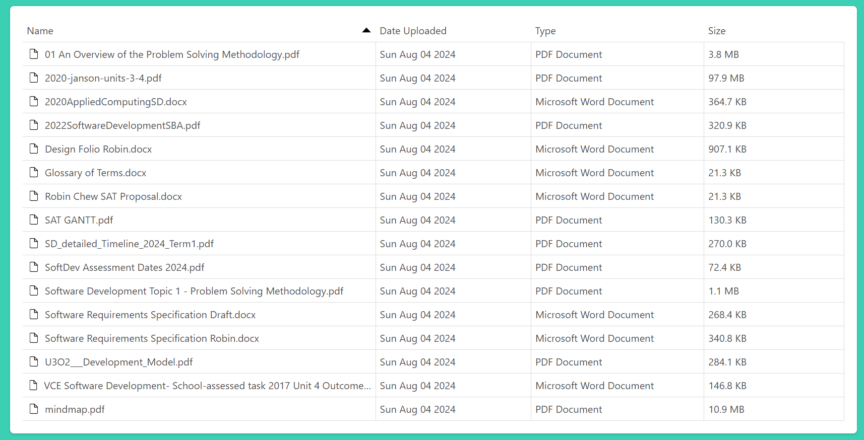

Sorted by Type, Ascending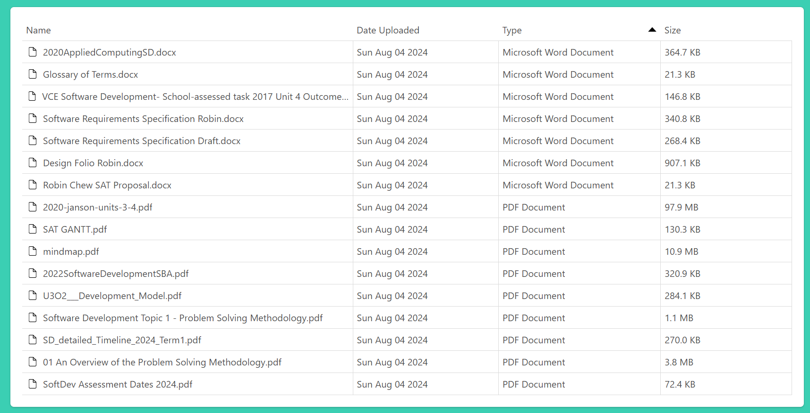

### Sorted by Size, Descending

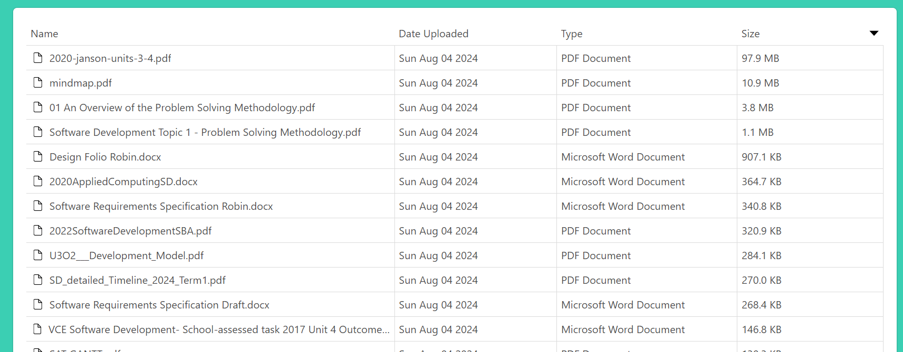

## Checking Filenames (Maintainability)

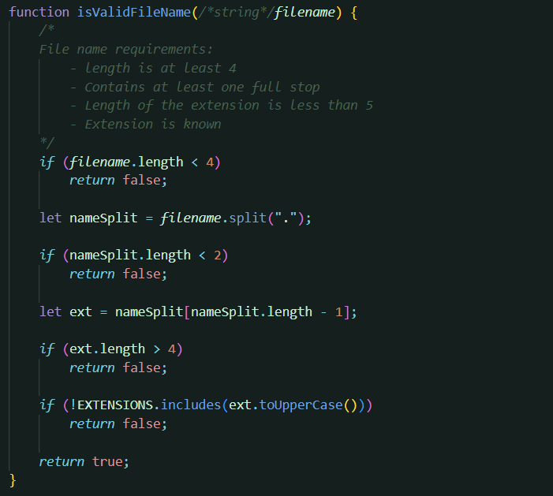

Despite the listed criteria, each if statement is actually a negation of the original criterion! This is done to remove nested if statements, which can be very unreadable. Instead of checking all criteria and returning true, If a single criteria is not met, it will single false.

Readability ensures greater maintainability.

## Formatting File Size, Date, and Time

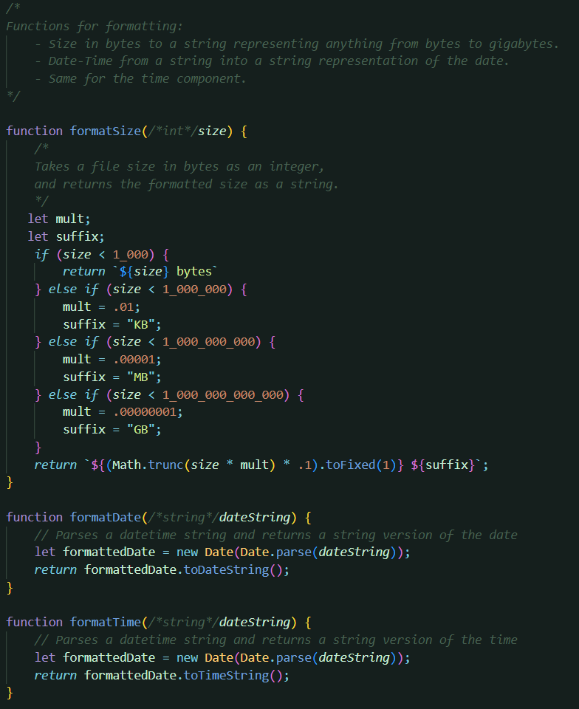

To enhance user experience, the file sizes are formatted to represent one of the standard units of file size (bytes, KB, MB, GB), instead of just showing the number of bytes.

The date would usually be shown as the date and time joined together, but as many have said, less is more. So only the date is shown, and if the user hovers over the date, then a tooltip will show its time as well.

## Interface

### Menu

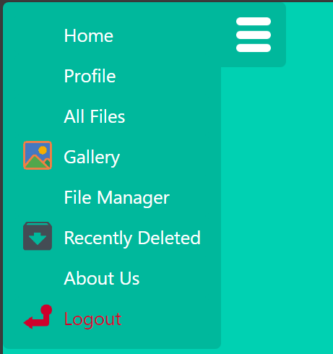

### Profile

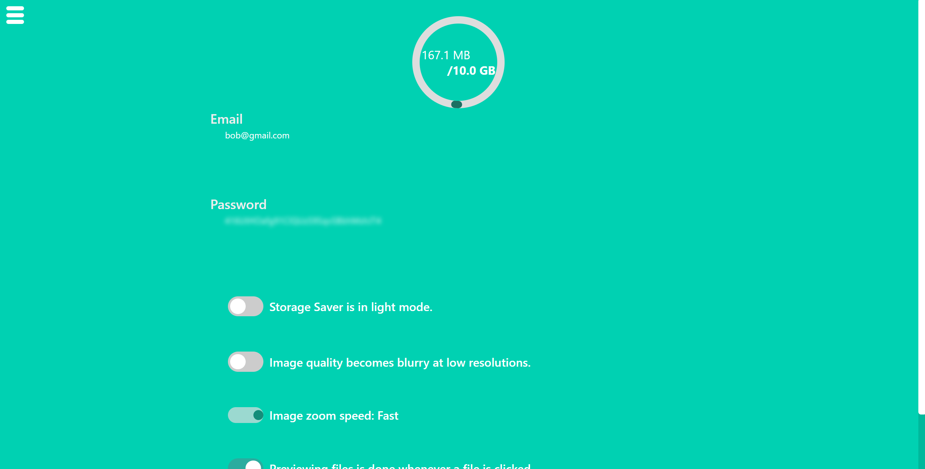

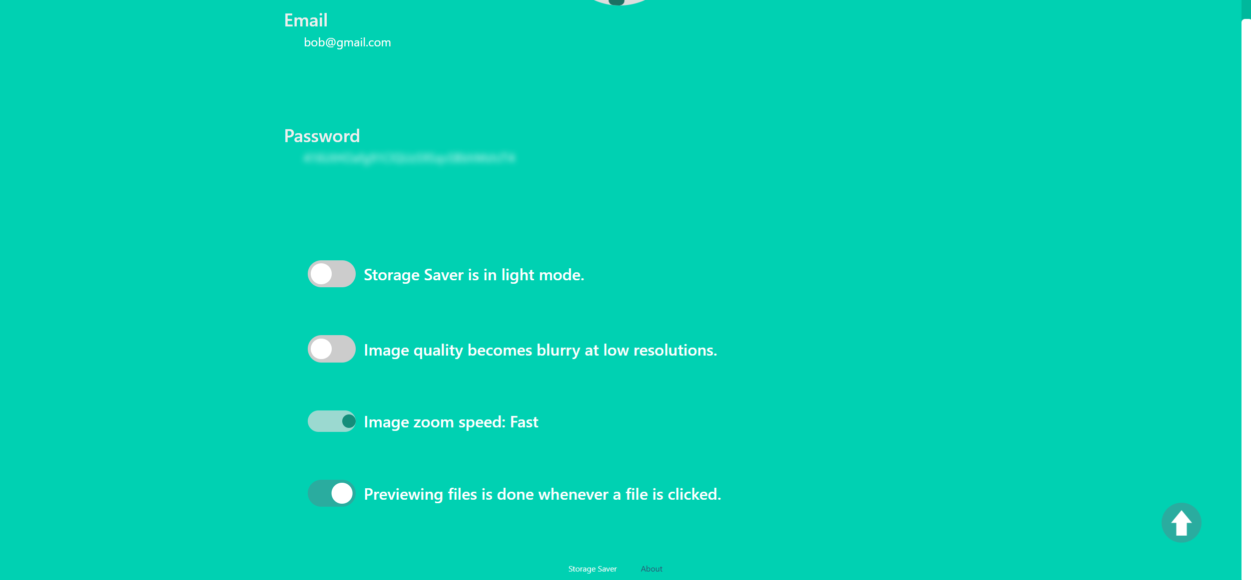

Scroll to top button if user has scrolled down at all.

### All Files

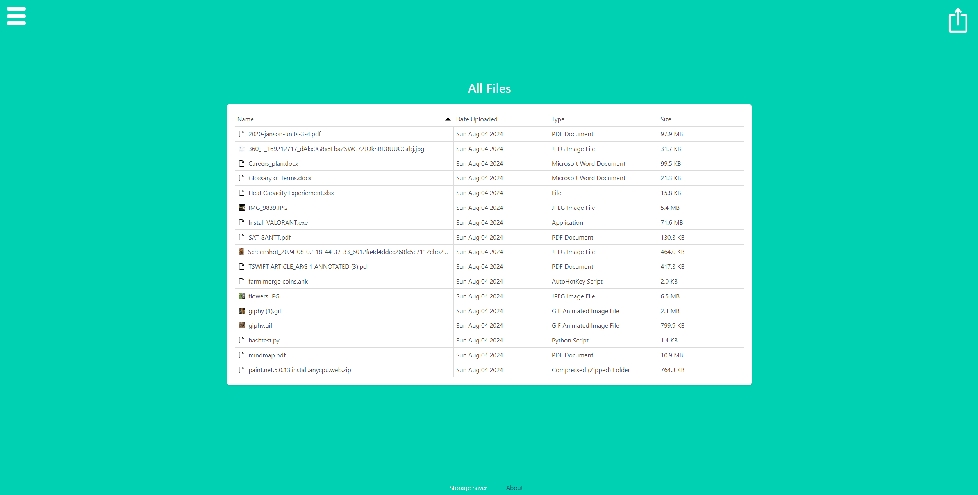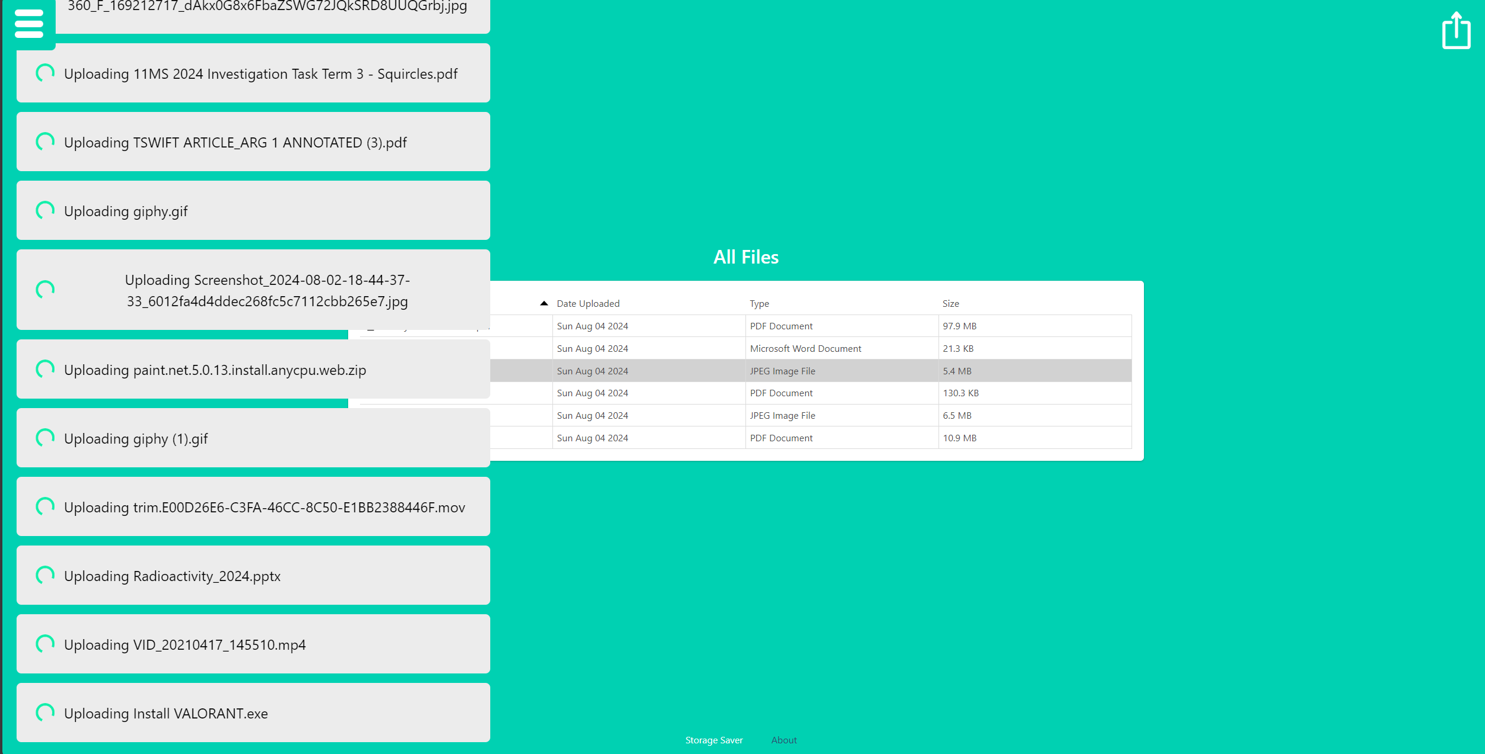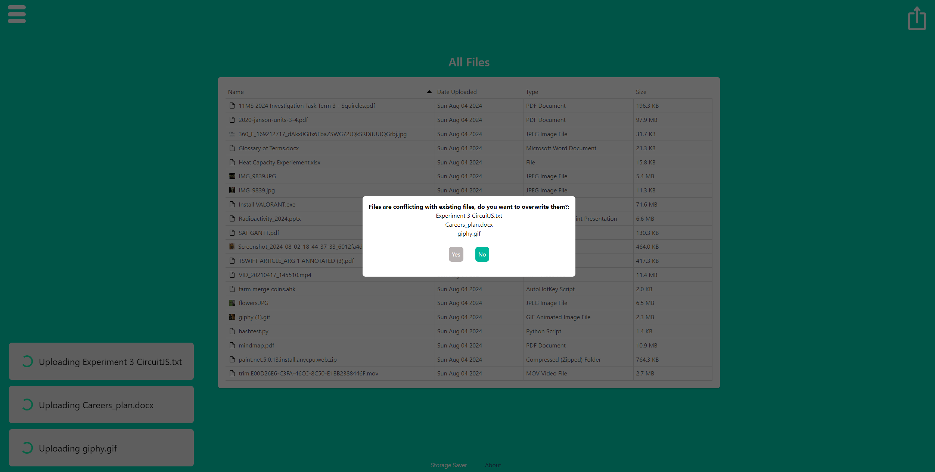

Overwrite notification appears when an upload request is met with conflicting file names.

Upload notification queue with buffering icon.

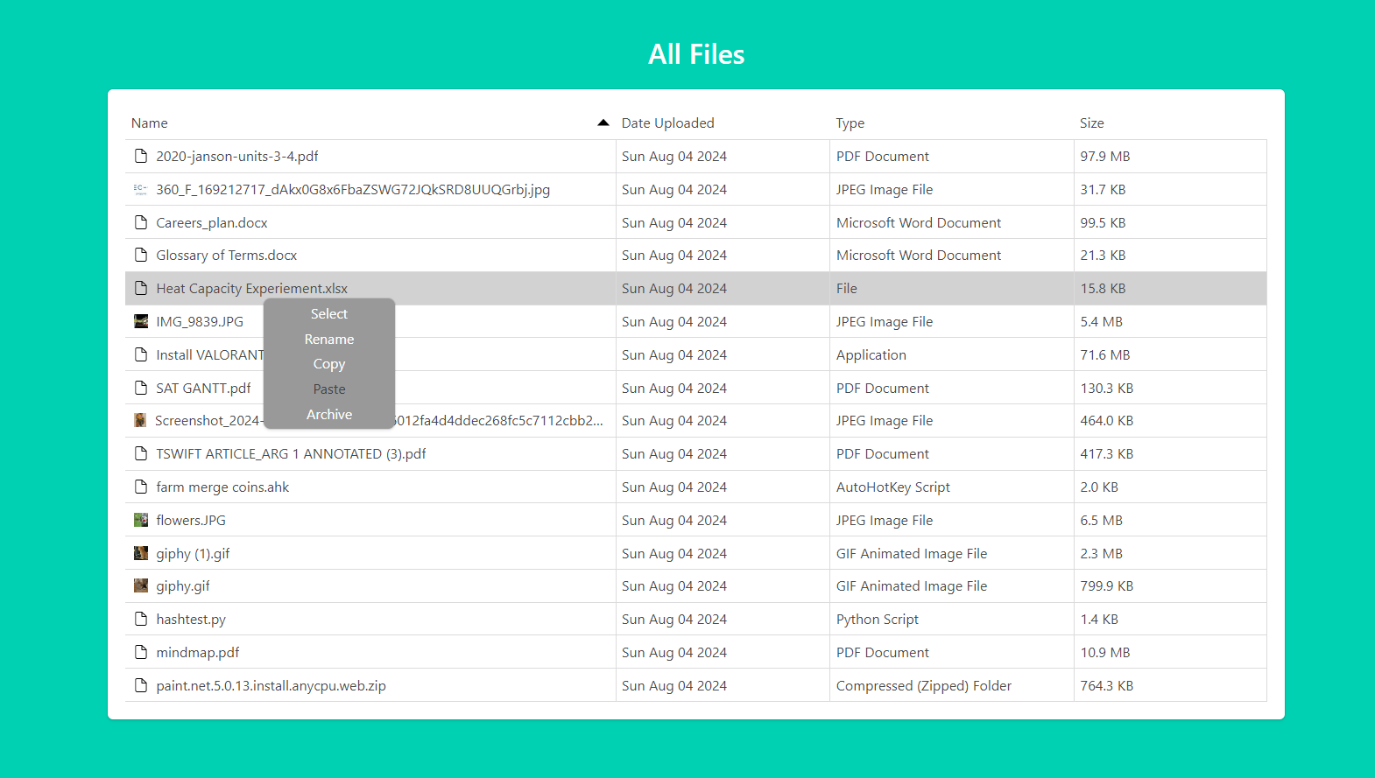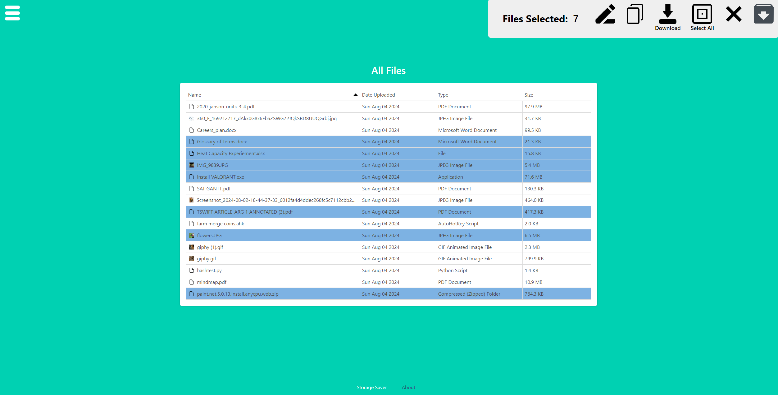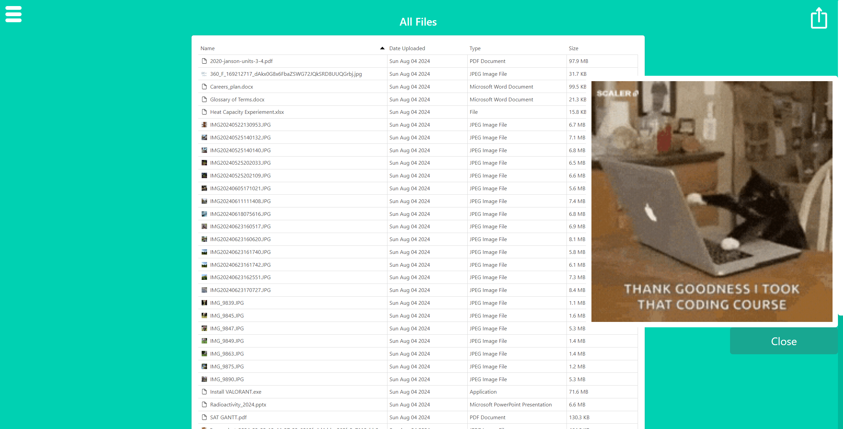

All Files – file preview

If multiple files are selected, a file selection frame appears.

Context menu whenever a file is right-clicked.

### Gallery



If multiple files are uploaded in the photo gallery, they are all joined together in the notification.

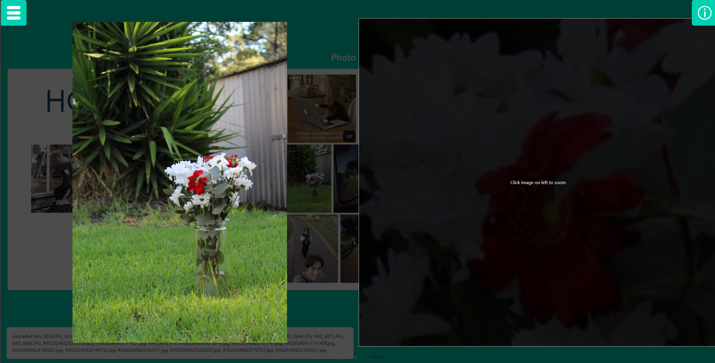



The user is able to zoom into images with this image viewer preview.

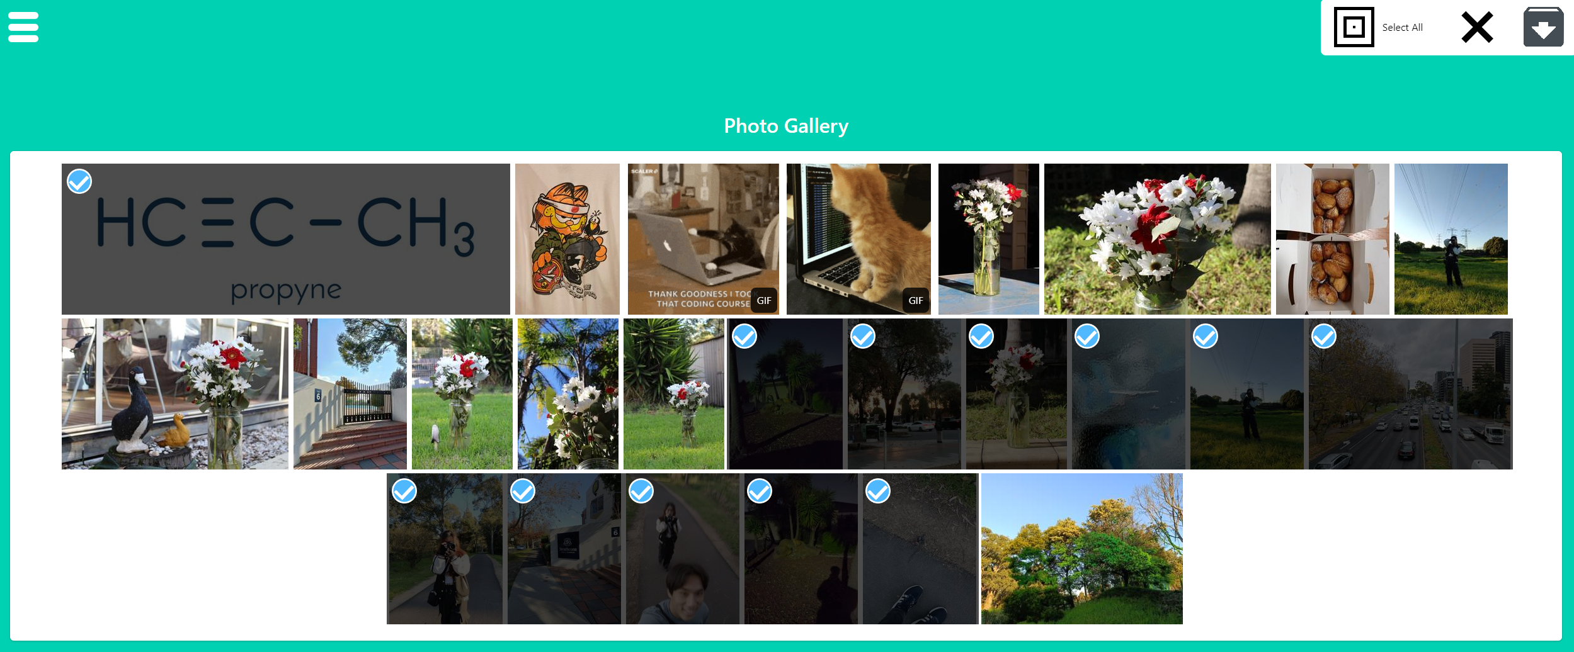

This is what it looks like to select images in the gallery.

### File Manager

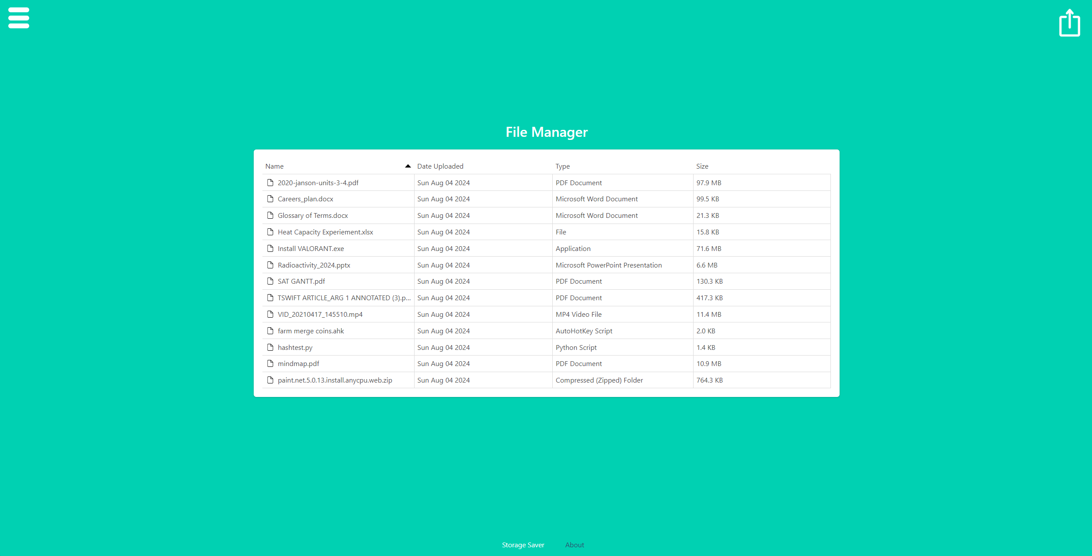

The file manager is similar to the ‘All Files’ page except for the images. This is to remove clutter for file management.

File preview in the file manager. This is the same in the recently deleted section.

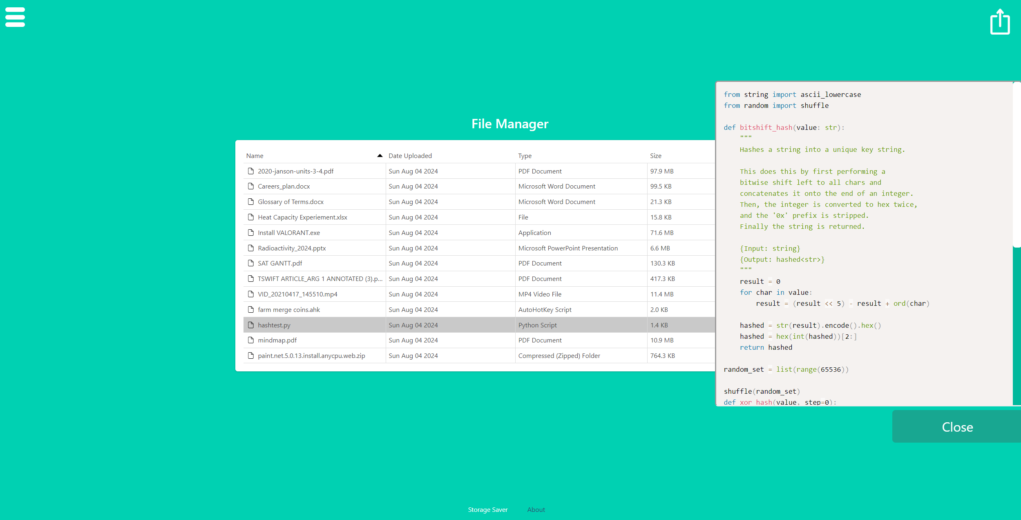

### Recently Deleted

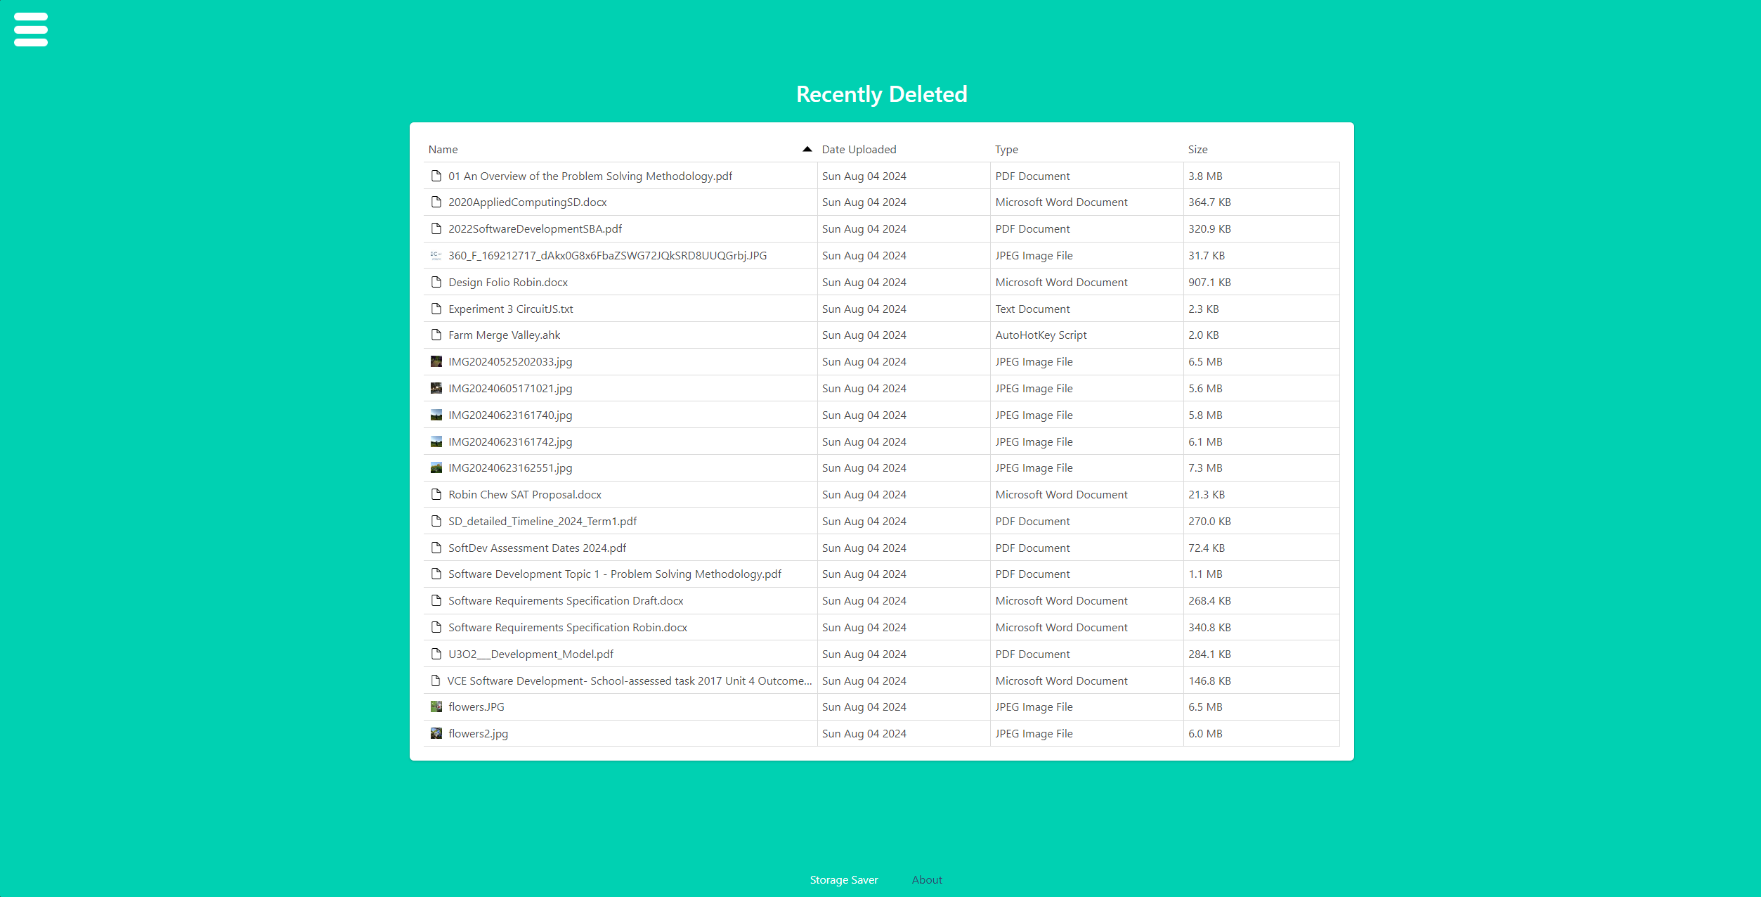

### About Us

